Machine Learning

1. Introduction

The world Machine Learning (ML) itself tells that it is a technology which focuses on the use of data and algorithms to imitate the way humans learn, gradually improving its accuracy. Machine Learning is a branch of **‘Artificial Intelligence’** and **‘Computer Science’**. The primary aim behind machine learning is to make a computer do useful things without specifically programming it to do so. In a glance, machines are acquiring new knowledge through an artificial system. According to this, the computer independently generates knowledge from experience and can independently find solutions to new and unknown problems.

In order to achieve this, a computer program analyzes examples and demonstrates use of self-learning algorithms to try to identify certain patterns, regularities and similarities in the data. The goal behind Machine Learning is to intelligently link data with one another, recognize relationships, draw conclusions, and make predictions. Like humans, a computer is also able to identify objects or differentiate between people when faded with data and then trained. The learning software constantly receives feedback from the programmer, which the algorithm uses to adapt and optimize the modal : with each new data set, the modal becomes better and ultimately distinguishes objects, uniquely identifies people and many more as well. Ability to process complex relationships between the input and output of large amounts of data is one of the main advantages of Machine Learning. Identification of spam, Recommending products, Customer segmentation, Image and Video Recognition, Fraudulent transactions, Demand Forecasting, Virtual Personal assistant, Sentiment analysis, ,Customer service automation are some of the trending applications of Machine Learning in the 20th century.

This paper is written in order to fulfill and explain the principles behind Machine Learning to the brilliant minds of our country so that they can also contribute their research in this field. The extent to which life had become luxury, restful and the rapid development in problem solving with the help of Machine Learning, use of Robotics, Health Sector, Agriculture, IT industry, Automobiles inspired us to write this research paper.

History

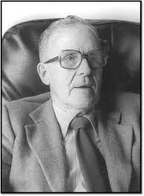 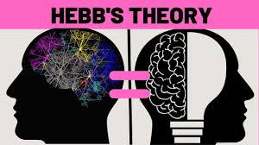

Donald Hebb (22 july 1904) Hebb’s Theory of Organisational Behaviour

Machine Learning is, in part, based on a model of brain cell interaction created by Donald Hebb in his book named **‘The Organization of Behaviour’** in 1949 which presents theories on neuron excitement and communication between neurons. Hebb wrote, “When one cell repeatedly assists in firing another, the axon of the first cell develops synaptic knobs (or enlarges them if they already exist) in contact with the soma of the second cell.”

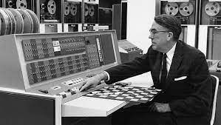 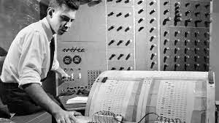

Arthur Samuel (IBM) Frank Rosenblatt (Perceptron)

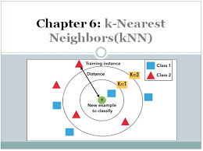

Nearest Neighbour Algorithm (1967)

An IBM employee and pioneer in the field of computer gaming and artificial intelligence, Arthur Samuel first came up with the phrase Machine Learning in 1952. Frank Rosenblatt – at the Cornell Aeronautical Laboratory – combined Donald Hebb’s model of brain cell interaction with Arthur Samuel’s machine learning efforts and created the perceptron in 1957. In 1967, the nearest neighbour algorithm was conceived, which was the beginning of basic pattern recognition. This algorithm was used for mapping routes and was one of the earliest algorithms used in finding a solution to the travelling salesperson’s problem of finding the most efficient route whose credit goes to ‘Marcello Pelillo’. In the late 1970s and early 1980s, [artificial intelligence](http://www.dataversity.net/artificial-intelligence-ai/) research had focused on using logical, knowledge-based approaches rather than algorithms. The industry goal shifted from training for artificial intelligence to solving practical problems in terms of providing services. Its focus shifted from the approaches inherited from AI research to methods and tactics used in probability theory and statistics. During this time, the ML industry maintained its focus on neural networks and then flourished in the 1990s.

“Boosting” was a necessary development for the evolution of machine learning. [Boosting algorithms](https://www.analyticsvidhya.com/blog/2015/11/quick-introduction-boosting-algorithms-machine-learning/) are used to reduce bias during supervised learning and include ML algorithms that transform weak learners into strong ones. The concept of boosting was first presented in a 1990 paper titled “The Strength of Weak Learnability,” by Robert Schapire. Some of the examples include BrownBoost, LPBoost, TotalBoost, xgboost and LogitBoost and AdaBoost being the most popular.



Speech Recognition



Google Speech Recognition



Facial Recognition

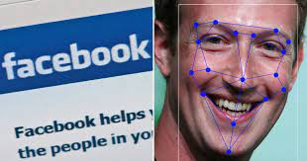

Facebook Deepface

A significant development was the innovation of Speech Recognition done by Deep Learning technique called long-short-term-memory (LSTM), a neural network model described by Jurgen Schmidhhuber and sepp Hochreiter in 1957 and it can learn tasks that require memory event that took place thousands of discrete steps earlier, which is quite important for speech. In 2015, the Google speech recognition program reportedly had a significant performance jump of 49 percent using a CTC-trained LSTM. In 2006, the [Face Recognition Grand Challenge](https://www.nist.gov/programs-projects/face-recognition-grand-challenge-frgc) – a National Institute of Standards and Technology program – evaluated the popular face recognition algorithms of the time. In 2012, Google’s X Lab developed an ML algorithm that can autonomously browse and find videos containing cats. In 2014, Facebook developed DeepFace, an algorithm capable of recognizing or verifying individuals in photographs with the same accuracy as humans.

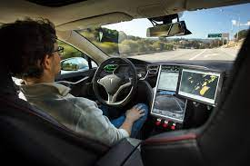 

Self driving cars Chatbots

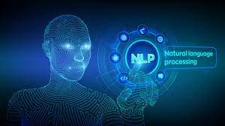

Natural Language Processing (NLP)

At present, ML is responsible for some of the most significant advancements in technology such as self-driving vehicles, identifying exoplanets, IoT, analytics tools, chatbots Fraud detection, product recommendations, dynamic pricing, natural language processing (NLP),decision making programs, real time mobile personalization, learning managment systems and many more.

Machine Learning History (yearwise development)

The era from 2000 till present has proved as golden era for innovation and key findings in Machine Learning. Researchers have published number of research papers, journals etc. in this period of last 22 years in the fields of Machine Learning. Few of the most important research includes Kernel Methods (2001),Computational Learning Theory (Nov 2002), Machine Learning methods for text and images (February 2003), Learning theory (Oct 2003), ML for computer security (Dec 2006), Grammer Induciton, Representation of Language and Language Learning (Nov-2010-Apr 2011), Learning from electronic health data (2016) and many more.Cuurently, researchres are working on Hyper automation which is an AI and ML trend that use auto-generated learned algorithms and trained robotics to reduce dependency and ensures accuracy, validity and speed. At present, the aim of researchers is focusing on exploring useful data structures and algorithms, and making interesting statistical and learning methods applicable on small and large volumes of data.

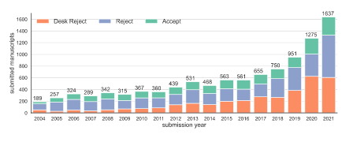

Number of papers submitted each year (2004-2021)



Hyper automation

Materials and Methods

Results and Discussion

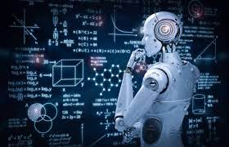

Machine learning

Machine learning (ML) is **a** type of artificial intelligence (AI) that allows software applications to become more accurate at predicting outcomes without being explicitly programmed to do so with the help of historical data as input.

Types of Machine Learning :

Machine Learning Models :

Performing Machine Learning involves creation of model, which is trained on some training data and then can process additional data to make predictions. Some of the well known models include :

Artificial Neural Networks :

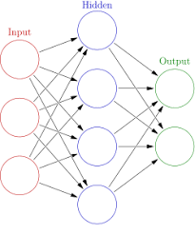

Artificial Neural Networks

Artificial neural networks (ANNs), or [connectionist](https://en.wikipedia.org/wiki/Connectionism) systems, are computing systems vaguely inspired by the [biological neural networks](https://en.wikipedia.org/wiki/Biological_neural_network) that constitute animal [brains](https://en.wikipedia.org/wiki/Brain). Such systems "learn" to perform tasks by considering examples, generally without being programmed with any task-specific rules.

This model is based on a collection of connected units or nodes called "[artificial neurons](https://en.wikipedia.org/wiki/Artificial_neuron)", which loosely model the [neurons](https://en.wikipedia.org/wiki/Neuron) in a biological [brain](https://en.wikipedia.org/wiki/Brain). Each connection, like the [synapses](https://en.wikipedia.org/wiki/Synapse) in a biological [brain](https://en.wikipedia.org/wiki/Brain), can transmit information, a "signal", from one artificial neuron to another. An artificial neuron that receives a signal can process it and then signal additional artificial neurons connected to it.

The original goal of the ANN approach was to solve problems in the same way that a [human brain](https://en.wikipedia.org/wiki/Human_brain) would. Artificial neural networks have been used on a variety of tasks, including [computer vision](https://en.wikipedia.org/wiki/Computer_vision), [speech recognition](https://en.wikipedia.org/wiki/Speech_recognition), [machine translation](https://en.wikipedia.org/wiki/Machine_translation), [social network](https://en.wikipedia.org/wiki/Social_network) filtering, [playing board and video games](https://en.wikipedia.org/wiki/General_game_playing) and [medical diagnosis](https://en.wikipedia.org/wiki/Medical_diagnosis).

Decision Trees :

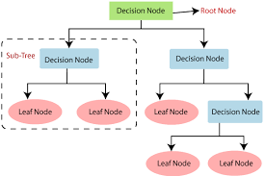

Decision Trees

Decision tree learning uses a [decision tree](https://en.wikipedia.org/wiki/Decision_tree) as a [predictive model](https://en.wikipedia.org/wiki/Predictive_modelling) to go from observations about an item (represented in the branches) to conclusions about the item's target value (represented in the leaves). It is one of the predictive modeling approaches used in statistics, data mining, and machine learning.

Bayesian networks

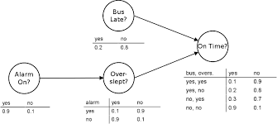

Bayesian networks

A Bayesian network, belief network, or directed acyclic graphical model is a probabilistic [graphical model](https://en.wikipedia.org/wiki/Graphical_model) that represents a set of [random variables](https://en.wikipedia.org/wiki/Random_variables) and their [conditional independence](https://en.wikipedia.org/wiki/Conditional_independence) with a [directed acyclic graph](https://en.wikipedia.org/wiki/Directed_acyclic_graph) (DAG).

Bayesian networks that model sequences of variables, like [speech signals](https://en.wikipedia.org/wiki/Speech_recognition) or [protein sequences](https://en.wikipedia.org/wiki/Peptide_sequence), are called [dynamic Bayesian networks](https://en.wikipedia.org/wiki/Dynamic_Bayesian_network). Generalizations of Bayesian networks that can represent and solve decision problems under uncertainty are called [influence diagrams](https://en.wikipedia.org/wiki/Influence_diagram).

Popular machine learning algorithms :

Linear Regression :

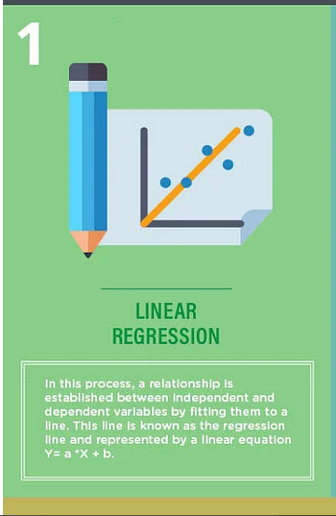

Linear Regression

A relationship is established between independent and dependent variables by fitting them to a line. This line is known as the regression line and represented by a linear equation Y= a *X + b.

In this equation:

* Y – Dependent Variable
* a – Slope
* X – Independent variable
* b – Intercept

The coefficients a & b are derived by minimizing the sum of the squared difference of distance between data points and the regression line.